Here is an example of heatmap that is similar to the one I am trying to create

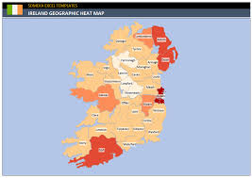

I like the colour scheme of this for the heatmap:



